Welcome Teacher!

The 2020-21 school year will surely be a challenge. As educators, we will need to support the needs of our students in new and evolving ways. Here are some resources to assist you.
Throughout the school year, Real Art Ways will be offering free Virtual Film “Field Trips” (which will be essentially the first part—the film viewing and facilitated discussion—of what you are experiencing in this PD.) You can read more about the films we offer here: https://www.realartways.org/education/film-field-trips/
Tina Parziale, our Education Manager, will be sending out some information about these “Field Trips,” but you can email her at tparziale@realartways.org at any time.

Thank you for your hard work! Stay safe and be well!
--The Real Team

Directions:
- Please look through the following materials in preparation for your Professional Development with Real Art Ways.
- Take the Implicit Biases Test
- Fill out the attached pdf “Teacher Common Belief Survey”
- Materials to bring: your Survey, paint (acrylic, watercolor, whatever you have, or just crayons/markers) paper (to paint/color on)

Overview:

- Inocente Resources
- The Importance and Impact of Arts Education
- Recognizing Implicit Biases
- Honoring Student Knowledge and Experience
- Social and Emotional Learning
- Value-based Behavior Management

Inocente Resources:

http://inocentedoc.com/arts-education/
https://www.areasontosurvive.org/our-programs/arts-after-school/

Recognizing your Implicit Biases:

Scientific research has demonstrated that biases thought to be absent or extinguished remain as "mental residue" in most of us. Studies show people can be consciously committed to egalitarianism, and deliberately work to behave without prejudice, yet still possess hidden negative prejudices or stereotypes.

A growing number of studies show a link between hidden biases and actual behavior. In other words, hidden biases can reveal themselves in action, especially when a person's efforts to control behavior consciously flags under stress, distraction, relaxation or competition.

Hidden Bias Tests measure unconscious, or automatic, biases. Your willingness to examine your own possible biases is an important step in understanding the roots of stereotypes and prejudice in our society.

Think about:
-Start by taking some of these tests-
Psychologists at Harvard, the University of Virginia and the University of Washington created "Project Implicit" to develop Hidden Bias Tests—called Implicit Association Tests, or IATs, in the academic world—to measure unconscious bias. There are tests that test for bases based on race, gender, etc. You will have to register your email.
https://implicit.harvard.edu/implicit/

-Next take 10 minutes to fill out the attached pdf “Teacher Common Belief Survey”. Go with your gut reactions, don’t overthink or judge your answers. These will remain private, being honest and non-judgmental of yourself is paramount.

Honoring Student Experience:
Let’s begin by looking specifically at honoring student experience. A culture that honors student experience includes the following:
- A sense of openness and cultural humility
- An asset-based view of youth, groups or experiences that may be unfamiliar
- A commitment to avoiding and challenging stereotypes
- A willingness to let students define their own identities
One way of honoring student experience is to have students share their own stories and experiences.
Another way to make room for students to talk about their experiences is to talk about yours. There is great power in the authentic, thoughtful sharing of personal anecdotes by teachers. Choose stories carefully, keep them relatively brief and communicate them at a level that invites appropriate student sharing.
Think about:
What stories could you share?

Shared Inquiry and Dialogue:
Watch this video: https://vimeo.com/80839369
A classroom that bases itself on shared inquiry and dialogue has five main components:
1. Listening: deeply listening to what others say and to the feelings, experiences and wisdom behind what they say.
2. Respect: trusting the integrity of others, believing they have the right to their own opinions (even when different from your own), and valuing them enough to risk sharing your own ideas.
3. Humility: recognizing that our own ideas and opinions are only a part of the story and that other people may have access to pieces of the puzzle that we don’t know about.
4. Voice: speaking the truth as we see it and asking questions about things we don’t know or understand—particularly on topics related to identity, difference, power and justice.
5. Trust: building a safe environment to try on new ideas and work through the conflicts, controversy and “ouch moments” that often arise in talking about difficult topics.
Think about:
Think about discussion in your classroom. Do you do most of the talking? Do your students respond and react to their peers’ comments?
Take a minute to review the five components of shared inquiry and dialogue.
With each component in mind, brainstorm ways to encourage participation from your students. In the right column, list at least one option for each component.
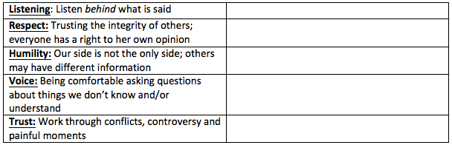

Social and Emotional Safety:
There are multiple ways to create a safe environment:
- Teach social-emotional skills
- Actively create positive relationships
- Practice bullying prevention and intervention
- Build community
- Focus on understanding and appreciating differences
- Engage in meaningful conflict resolution
- Teach students to challenge bias and exclusion and to stand up for each other as allies
Research shows that students need to feel both physically and emotionally safe to learn; safety includes being free from the threat of stereotypes, harassment and exclusion. Safety is especially important when learning about issues of identity, power and justice. Many of these issues touch students at a personal level and leave them feeling simultaneously vulnerable and passionately invested. Creating a safe climate takes time and work on the part of both teachers and students.
Think about:
How will you incorporate these components into your classroom routines?
Choose one area to focus on and plan for how to integrate it into your teaching and classroom management.
More learning:
I came across this opportunity for Social Emotional Learning Training being offered free of charge to CT school staff from Yale Center for Emotional Intelligence.
http://ctafterschoolnetwork.org/selcourse/

Values-based Behavior Management:
Values-based behavior management is a critical practice that asks you to consider five key principles of behavior management that support and model the values of anti-bias education:
- Belief in the dignity of every person
- Community building
- Equity and fairness
- Respect for cultural differences
- Respect for the safety and inclusion of all individuals and groups
There are many ways to infuse these values into disciplinary practices. All teachers need to build on their own personal styles to design appropriate classroom management systems. Generally, however, there are three primary aspects of this work:
- All classes must commit to creating a safe, inclusive community where all students and teachers are respected.
- Disciplinary incidents must be treated as opportunities for growth, restitution and community building (not just “punishment”).
- Behavior management practices must address issues of fairness, equity and cultural awareness.
Taking a values-based approach to behavior management and discipline supports the community-building goals embedded in culturally responsive teaching. It also provides students with exposure to a system of justice that values all people and seeks to build connections rather than divisions.
There are several strategies available to teachers to ensure values-based behavior management:
- Student-generated agreements and contracts establish shared ownership of classroom norms.
- Zero indifference (not zero tolerance) means never letting disrespectful conduct go by as though nothing has happened, but does not require automatic suspension, expulsion or other punishments that take kids out of class.
- Restorative justice emphasizes building community, repairing harm and restoring relationships rather than simply punishing those who have engaged in misconduct.
Classroom teachers can:
- Adopt a social-emotional lens.
- Know their students and develop their own cultural competence.
- Plan and deliver effective student-centered instruction.
- Move the paradigm from punishment to development.
- Resist the criminalization of school behavior.
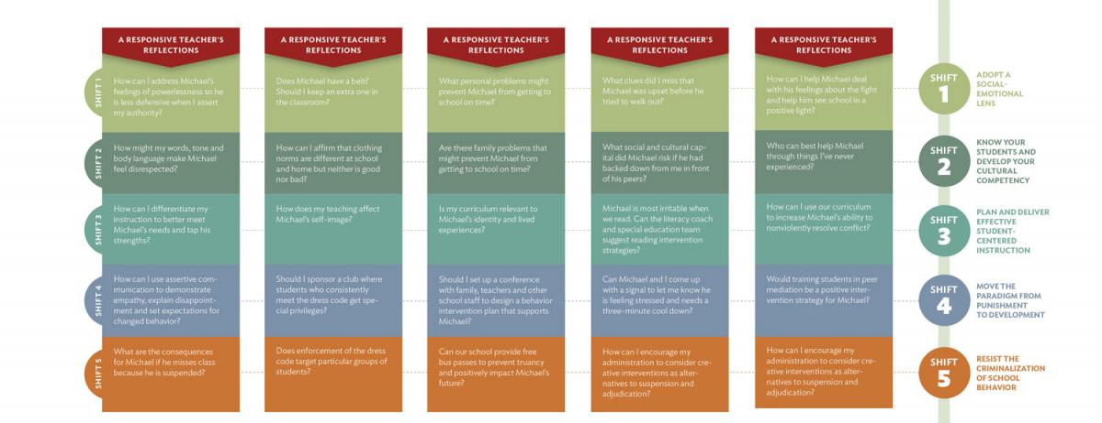

Think about:
Consider what current disciplinary measures you use. How could you implement the use of one of the aforementioned strategies: student-generated agreements, zero indifference, restorative justice and values-based classroom management shifts?
List challenges you might face in using one of the strategies. Identify supportive allies in your building.

Sources:
https://www.tolerance.org/professional-development/critical-practices-for-antibias-education-classroom-culture
https://www.tolerance.org/professional-development/test-yourself-for-hidden-bias

